**Last Day Linux Assignment “SHELL SCRIPT”**

Write a script that calculates the sum of two numbers entered by the user.  
  
2. Create a script that checks if a file exists in the current directory and prints a message accordingly.

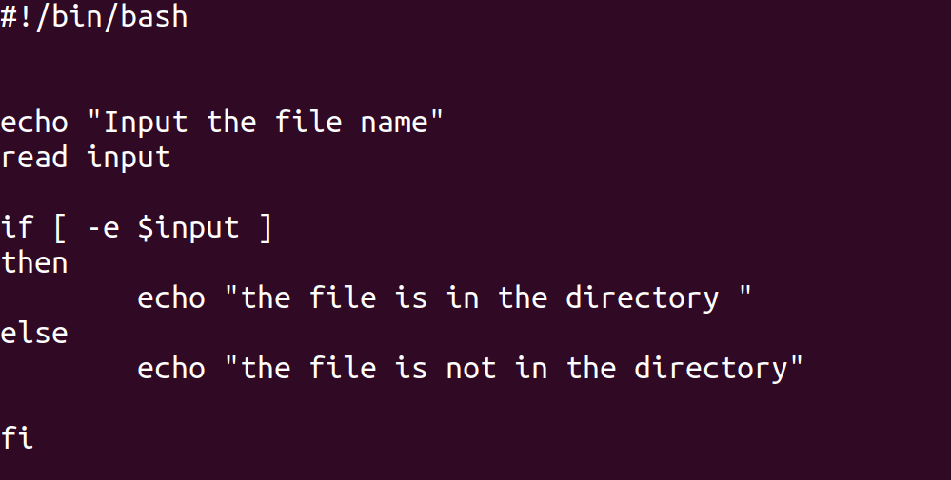

3. Write a script that lists all files in a directory and their sizes.

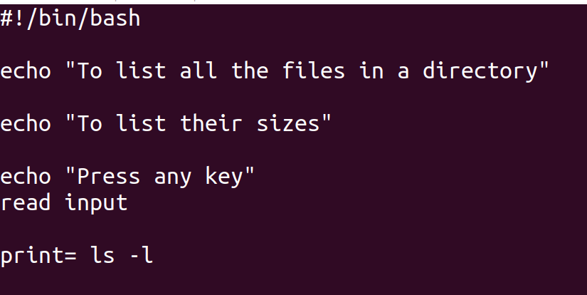  
  
  
4. Create a script that reads a text file and counts the number of lines in it.

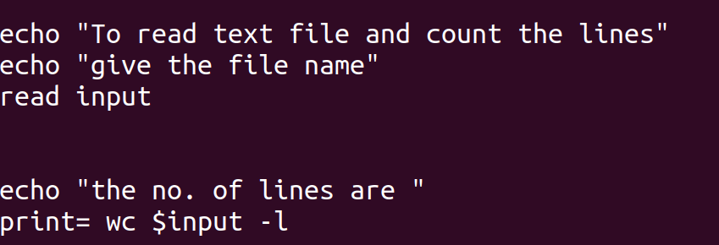  
Write a script that renames all files in a directory with a specific extension to have a new extension.

6. Create a script that checks if a given number is even or odd.

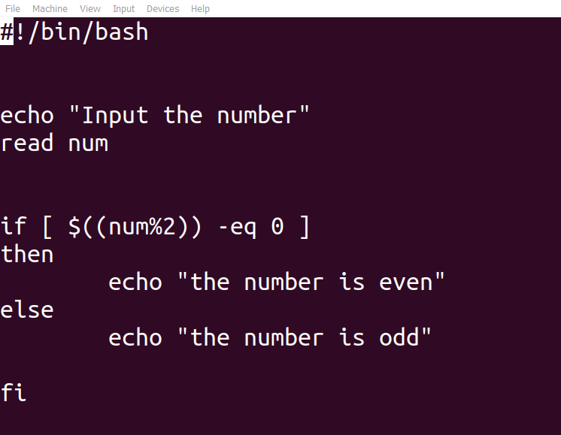  
Write a script that accepts a filename as an argument and checks if it's a regular file or a directory.  
  
7. Create a script that accepts a user's grade (A, B, C, D, or F) and provides a corresponding message (e.g., "Excellent," "Pass," "Fail," etc.).

Write a script that asks the user for their age and checks if they are a child (0-12 years), teenager (13-19 years), or an adult (20+ years).

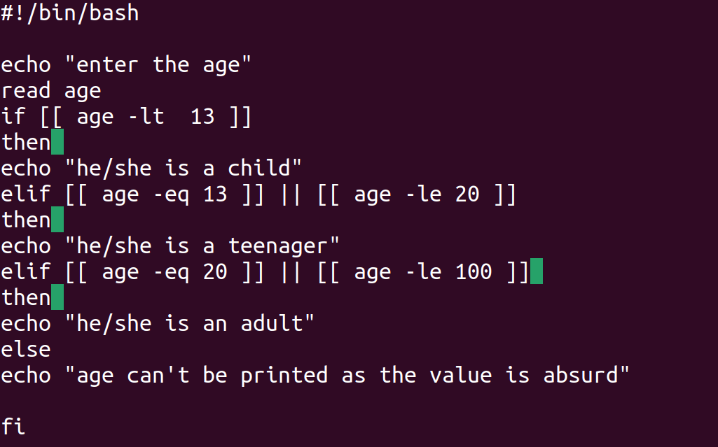  
  
Create a script that checks if a given string is empty or not, and displays a message accordingly.  
  
Write a script that calculates the area of a triangle based on user-provided base and height values.  
  
Write a shell script that displays a menu with options to add, subtract, multiply, and divide two numbers entered by the user. Implement each operation as a separate case in the menu.

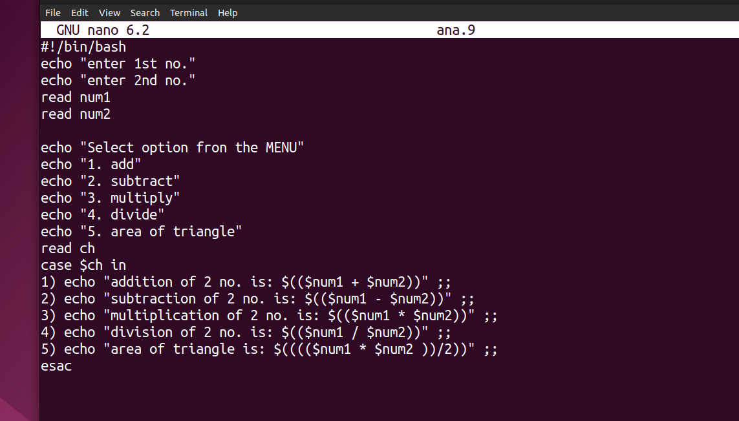  
  
Create a menu-driven script that allows the user to manage a to-do list. The menu should include options to add tasks, list tasks, mark tasks as completed, and exit the program.  
  
Develop a menu-driven program that simulates a basic file management system. Users should be able to create, delete, list, and navigate directories.